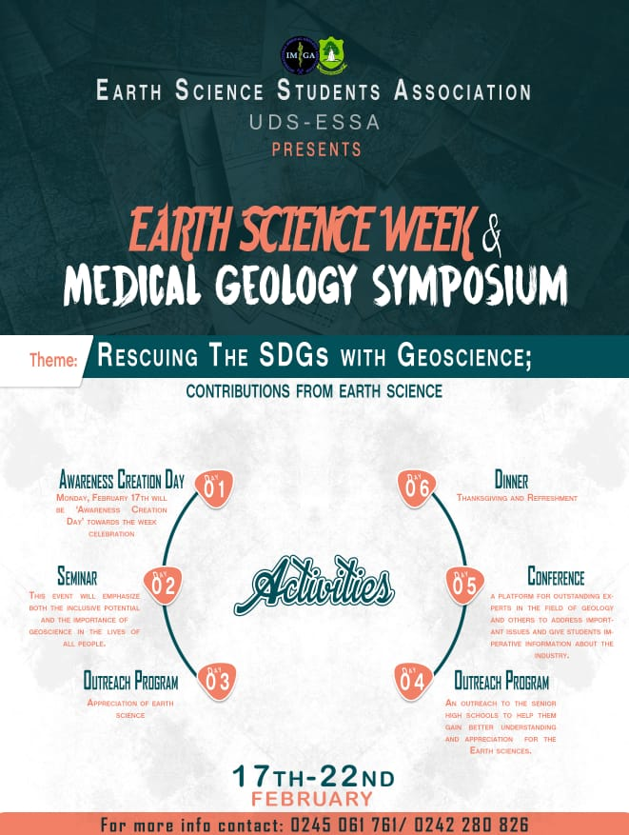
Fig. 1 The Programme outline (Four days conveying Medical Geology Agenda to Students)
This was a five day programme. Launching was done on the 16th February, 2020 (Fig. 2).

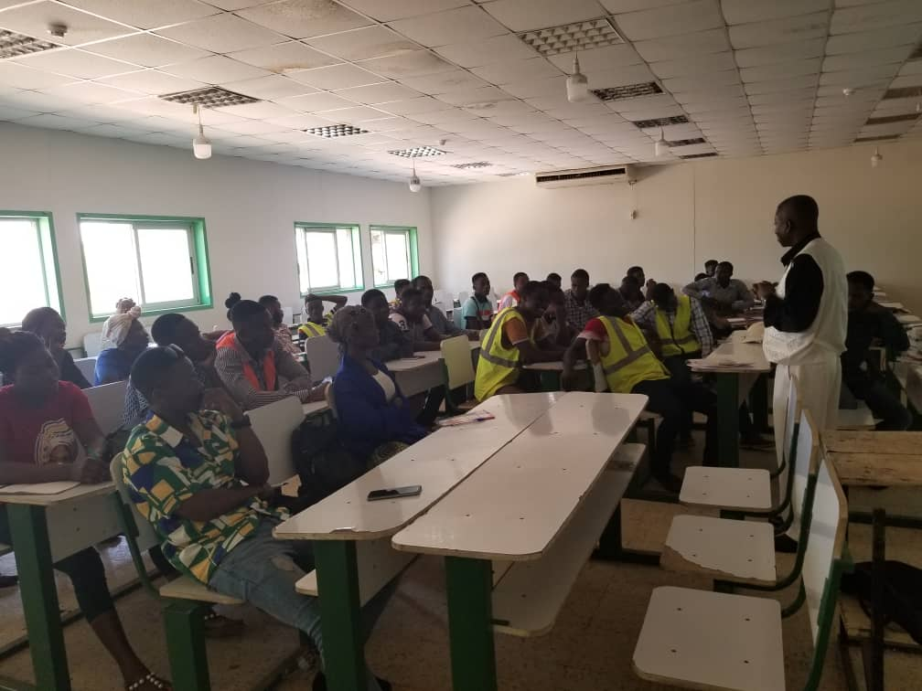
Fig. 2. The launch of the Earth Science Week and Medical Geology Symposium-Presentation by Chapter Leader.
The attendance was fifty but these numbers of people were able to communicate the impending program to many students on campus. The outreach saw us making presentations at the respective second cycle schools in Kassena Nankenna Municipal Assembly and other members doing same at the University of Ghana by Ghana Institution of Geoscientists (GhIG). The head teachers really appreciated the exercise that they have been requesting for the continuity of the programme. The Chapter thinks the formation of Medical Geology Students Club is long overdue and should be considered now. This will help the youth the think ‘environmental justice’ as they will understand what goes around comes around to haunt them. Let us accept the fact that the youth are the masters of social media. Therefore catching them young and grooming them to make medical geology agenda their own is similar to saying making the world safe. Figure 3 also shows some interactions among students and GhIG family of Earth Science Week and the importance of Medical Geology in making the earth a safe place to live.
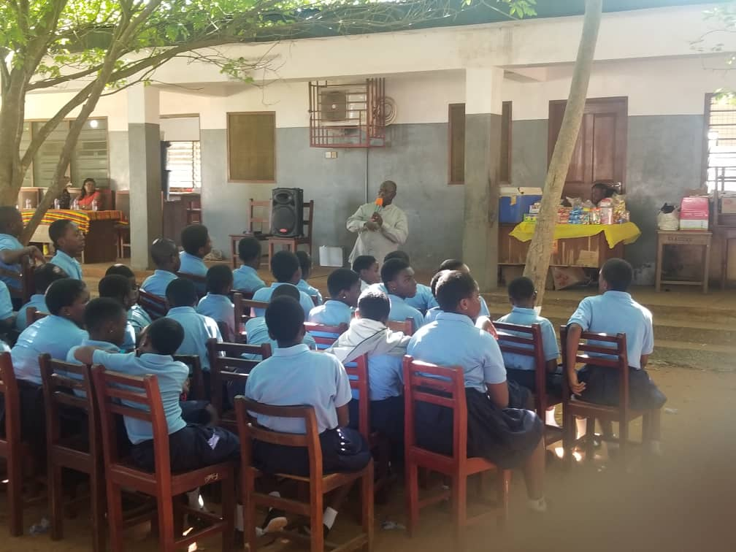
Fig. 3 The Executive Secretary of GhIG addressing a section of students on the importance of Earth Science
The second agenda of Ghana’s Chapter in the conveyance of the Medical Geology agenda was to get a bigger platform to communicate all the good things that IMGA is doing and will do by inviting the Regional Minister of the Upper East Region and the Municipal Chief Executive of Kassena Nankenna Municipal Assembly as Special Guest of honours, other dignitaries of national repute were invited as keynote speakers. Though the idea was to convey and internalize Medical Geology Association in Ghana but we also tried to bring in some international flavor to the whole activities by requesting a video of the IMGA President choice to be played to the participant (Video 1-from Diego F). This inclusion was another diversion of the use of social media in reaching out to the world. The audience at the symposium that day recognized the level of internationalization of the medical geology association. Again to make sure the notion of medical geology not belonging to only geologist but being a multidisciplinary branch of applied science was demonstrated by a presentation from the Chapter leader Prof. Emmanuel Arhin (Fig. 4). We had over 250 participants. His topic was ‘Urbanization, flooding and public health’’ (presentation attached).
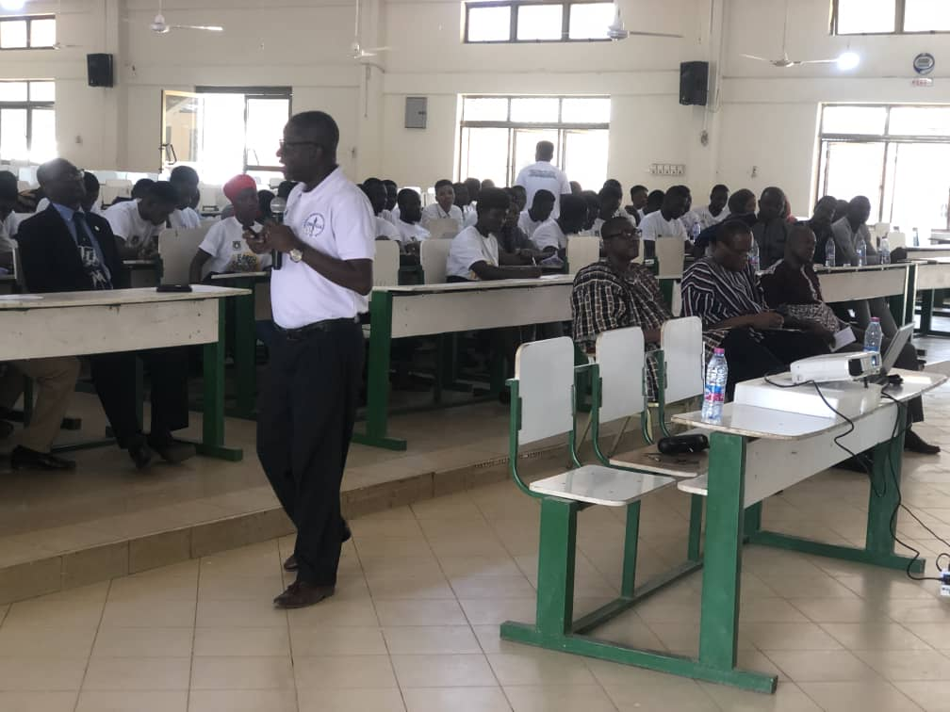
Fig. 4 The Chapter Leader-Ghana gave presentation on ‘Urbanization, flooding and health’ at the symposium.
The summary of speeches and presentations made by the guest of honours , keynote speakers and others as captured by national media house of Ghana, Ghana Broadcasting Corporation (GBC) and presented as a news item the following day went viral on the social media. The feedback we had was that the population had bought into the idea of prevention being better than cure. Though the news as presented by the news media was sketchy it is incumbent on us to propagate the medical geology agenda to the people.
Ghana Chapter will welcome a workshop by IMGA as it was done in 2007 to reach out to many people as Ghana seems to have a big laboratory for medical geology research. A sub regional conference in the sub Saharan Africa may not be bad but that will depend on our preparedness to do so. As part of the Association’s plans we wish to make the Association known at least in the Public, Private Universities and institutions that share our vision of making earth a safe haven for mankind. We have the IMGA flyers and with some local and international researches done by some individual IMGA members; we will be able to get more to join or follow IMGA activities. Impact of geological processes on health is least spoken off in Ghana. Awareness is very much needed particularly in Ghana. Geological and environmental processes coupled with the climate changes are affecting trace elements distributions and concentrations. Background values for potentially toxic elements (PTEs) and essential elements (EE) in specific rock types are unknown. Enrichment factors (EF) are calculated using average continental crustal values that appear too simplified and do not address specifically the background value at a place. Ghana Chapter intend to undertake a research to establish background values for some trace elements that are of environmental concerns typically in mine, agricultural, residential and urban areas. Collaborative researches with our international counterparts are welcome. We are making this appeal because of lack of research funding.

Yours faithfully,
Prof. Emmanuel Arhin
(Ghana Leader)

